Task 2

(Flask-elasticsearch demo)

USERS

GUIDE

Contributor(s):

Sandino C. Cardinoza

Table of Contents

MASTER LIST PAGE………………………………………………….. 1

HOW TO ADD NEW DOCUMENT …………………………….. 2

UPDATE DOCUMENT ………………………………………………..3

DELETE DOCUMENT ………………………………………………….4

BULK ADDING OF DOCUMENT…………………………………..5

1. MASTER LIST PAGE: <http://localhost:5000/documentlist>

Master list of all created document

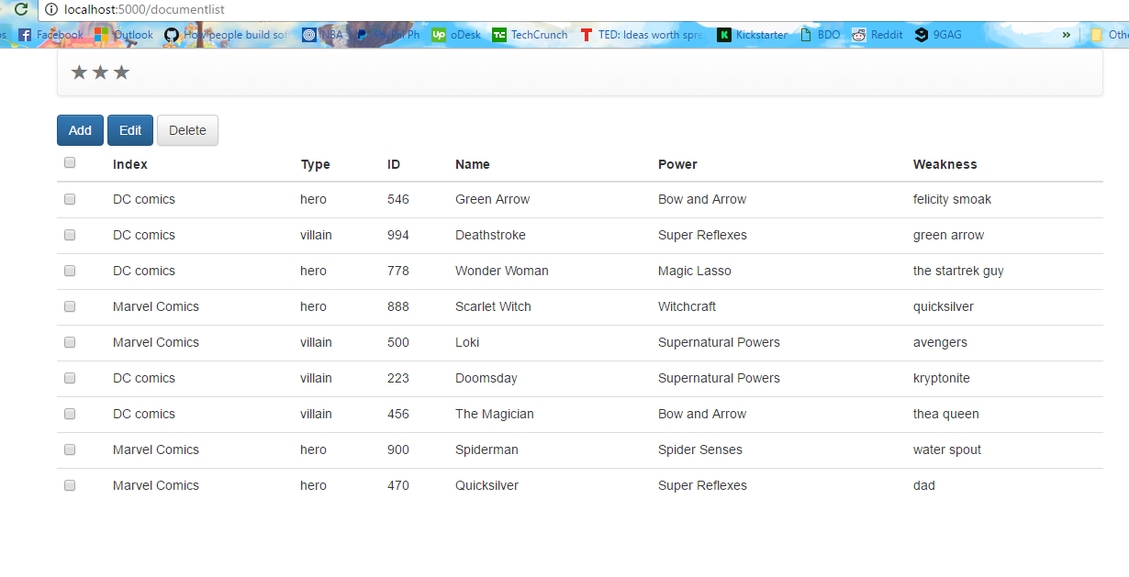

2. HOW TO ADD NEW DOCUMENT: <http://localhost:5000/>

* Click Add button (top-left of the screen)

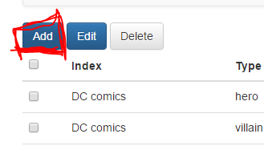

* Fillout the Form

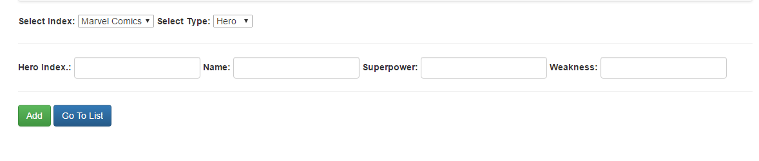

* Click Add button (after clicking it will redirect you to the same page just in case you want to add another document)
* If you want to go back to list just click Go To List button (in blue marker)

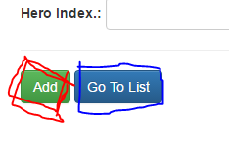

1. UPDATE DOCUMENT: <http://localhost:5000/documentlist>

* Check one or many (blue marker) document in the list then click Edit button (red marker)

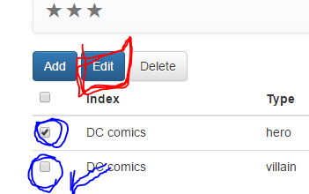

* A form will pop out and fill out the necessary fields that you want to update. Once done with the inputs go ahead and click Update button (lower – right corner of the pop out screen).

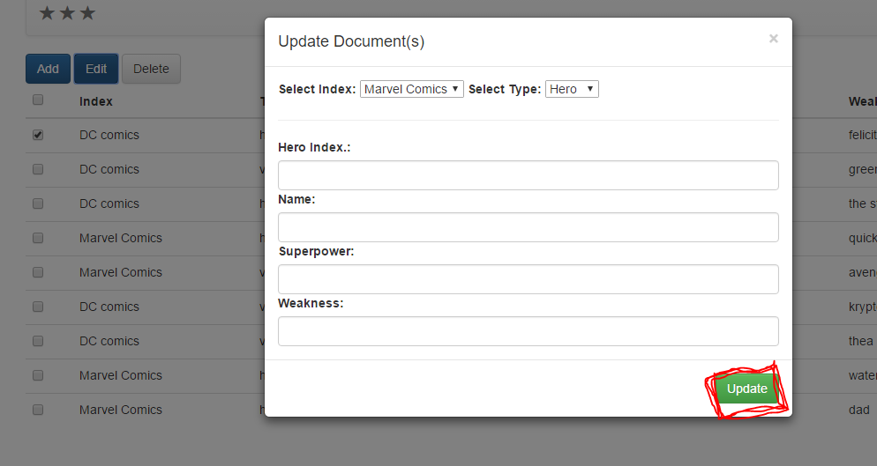

1. DELETE DOCUMENT: <http://localhost:5000/documentlist>

* Check one or many (blue marker) document in the list then click Delete button (red marker)

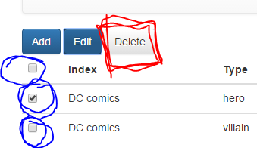

* This will pop out a confirmation message. Just click ‘Yes’ (red marker) to proceed, otherwise ‘No’ (blue marker)

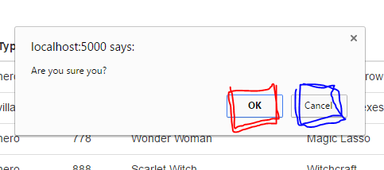

1. BULK ADDING OF DOCUMENT: <http://localhost:5000/documentlist>

* You need to call for an assistance with the System Administrator or Developer.
* For the System Adminstrator or Developer you need to run the following in a terminal.

curl -XPOST http://localhost:9200/_bulk?pretty=true --data-binary @path-to-your-file/t est.json; echo